|  |
| --- |
| CG GAMES |
| Assignment 2 – Monkey Ape |
| **[ 2D Platformer]** |
| Version #XX  All work Copyright © 2016 by CG Games.  All rights reserved. |
| **[Christopher Gelinas 300844877]** |
|  |



|  |
| --- |
| October 21 2016 |

**Table of Contents**

**Contents**

Game Overview

Game Play Mechanics

Camera

Controls

Interface Sketch

Screen Descriptions

Game World

Characters

Enemies

Items/Collectibles

Script Assets

Scoring

Sound Index

Story Index

Art / Multimedia Index

Future Features

# Game Overview

*Player assumes the role of a Sasquatch named M. Ape (Monkey Ape), amid a zombie outbreak. Sasquatch must avoid the zombies and any hostile hunters. Sasquatch’s goal is to eat as many bananas as possible while staying clear of zombies to avoid death.*

# Game Play Mechanics

*Stationary camera depicts entire level, the player can move forward, backward, and jump using the arrow keys. The player should flee from incoming zombies, and hunters before they hit the player. The amount of bananas eaten by Sasquatch is displayed as the player score.*

# Camera

*Stationary 2D eye level point of view.*

# Controls

*The player uses the keyboard’s directional keys to move left, and right. The player can jump with the space bar.*

# Interface Sketch

**(Original Concept - Some Game Mechanics Have Changed)**

# 

# Screen Descriptions

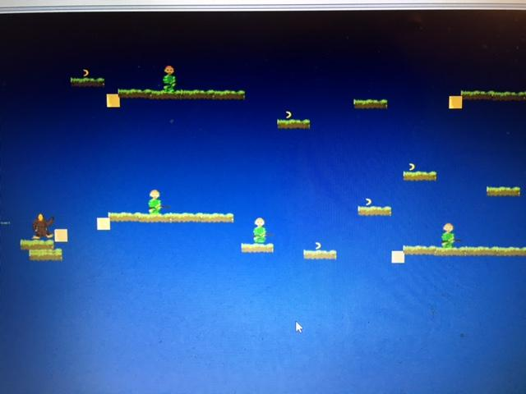

Player Start Point

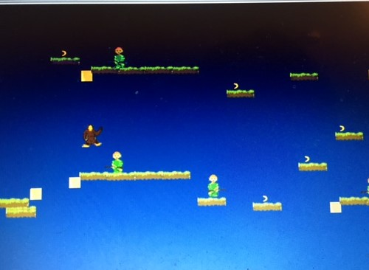

Player About to Collide With Enemy Hunter

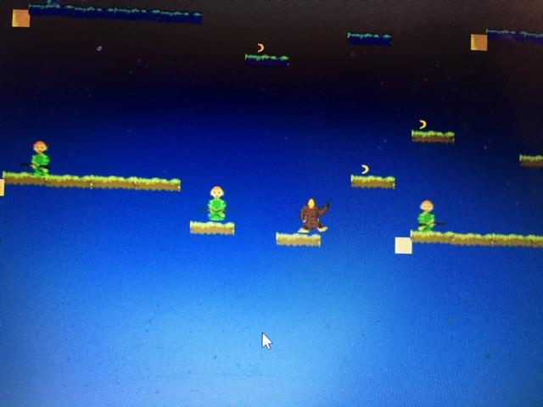

Player Respawn at Check Point

# Game World

*2D environment with jungle theme, game takes place during a zombie outbreak and the player avoids hunters and zombies, bananas spawn as collectible items for points.*

# Characters

*Sasquatch (Monkey Ape) - Player character which can run forward backward, and jump. This is the protagonist of the game, Ape Man tries to eat as many bananas as possible while avoiding enemies.*

# 

# Enemies

Zombies - Zombies patrol platforms, walking back and forth, they will speed up if the player falls in their line of sight.

Hunters - Hunters also patrol platforms, they act similar to zombies, walking back and forth along the platform, and speeding up once they see the player. They can move slightly faster than zombies.

# Items/Collectibles

Bananas - These items are to be collected by the Ape Man in order to gain extra points

# Script Assets

**PlayerController - Controls Player Behaviour**

**EnemyBehaviour - Controls Enemy Behaviour**

**CheckPointController - Controls checkpoint for player respawn**

**GameController - Controls GUI and Scoring/Lives**

# Scoring

Score is increased every time the player collects a banana item

# Sound Index

(All sounds created by me using GarageBand)

JumpSound - Plays when player jumps

DeathSound - Plays when player falls off platform

HurtSound - Plays when player collides with an enemy

BananaSound - Plays when player picks up banana

# Story Index

# Art / Multimedia Index

All sprite art was drawn by me using dottable and paint.net

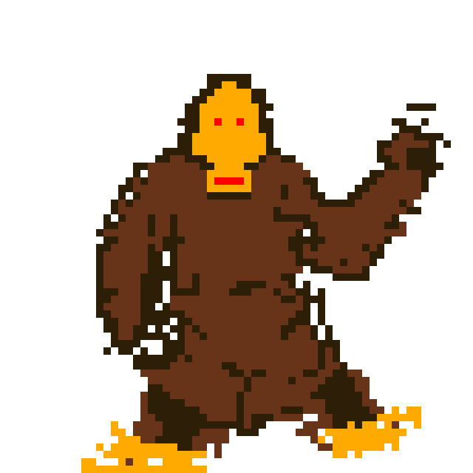

**Sasquatch (Monkey Ape)**

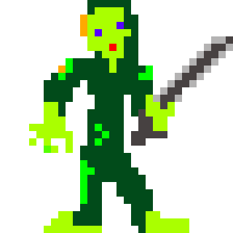

**Zombie**

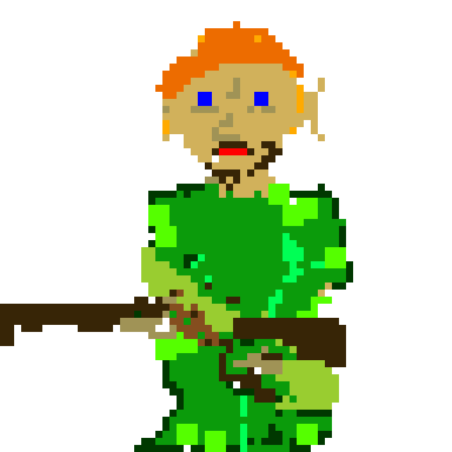

**Hunter**



**Platform**



**Banana**



**Bullet (unused)**

# Future Features

Future versions of this game could include new features such as additional levels, and a final boss. Giving the hunter the ability to fire bullets could also provide a greater challenge for the player.